**inSight 2017**

**Department : Department of Training and placements**

**Problem Title : Dynamic form for feedback.**

**Problem Code : PS07**

**Problem Description :**

Many Training programs like soft skills, aptitude, company specific trainings are given by the placement departments. In order to improve the quality of these training programs feedback plays a key role. An application should be developed in order to automize the feedback process. The application should provide option to generate a dynamic form which would help take the feedback specific to the training and should also be able to generate a report whenever required.

**Proposed solution:**

*(In this section, tell us how you are going to solve this problem, in about 400 words)*

*We will be devoloping a web application which would provide the administrator to create dynamic feedback forms and students could send their feedback by filling the feedback form.*

*Administrator can create a feedback back form by signing in using his userid and password.The feedback form can be created for a particular event [Soft skills, feel employable etc...].Any student can fill the feedback form in the website depending on the event he/she participated.*

*Reviews given by the student will be stored on to the database ,from which reports can be generated.*

**Technology Stack :**

*(In this section, tell us what technologies you are going to use and how)*

*We will be using:*

*HTML,CSS,Bootstrap,JavaScript.*

**Use Case:**

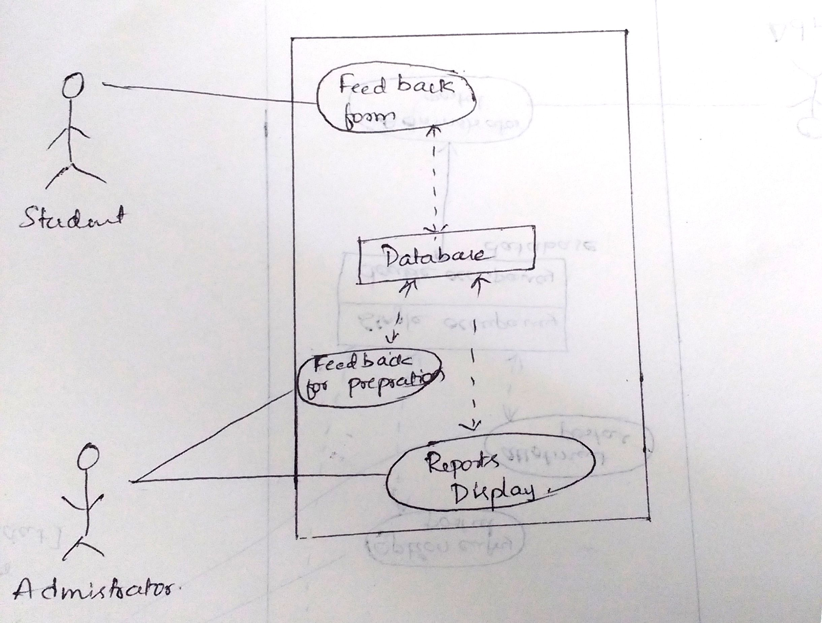

**Team Members details:**

|  |  |  |  |  |
| --- | --- | --- | --- | --- |
| **Role** | **Name** | **USN** | **Email id** | **Phone no.** |
| Team Leader | Purushotham G.K | 1SI15CS082 | purushotham.gkpl@gmail.com | 9590984828 |
| Team Member 1 | Bhuvan S | 1SI15CS139 | bhuvan.reddy98@gmail.com | 7795501929 |
| Team Member 2 | Rakshitha R | 1SI15CS086 | rakshita.ravi97@gmail.com | 8904547901 |